George Smith

Lab 4

Case Study 1 – No deliverable needed

Case Study 2:

OrderItem(Order Num, Line, Item Number, Description, Qty Ordered, Price Each)

Order (Order Num, Line, *Item Number*, Qty Ordered, Price Each)

Item (Item Number, Description)

Case Study 3:

a.

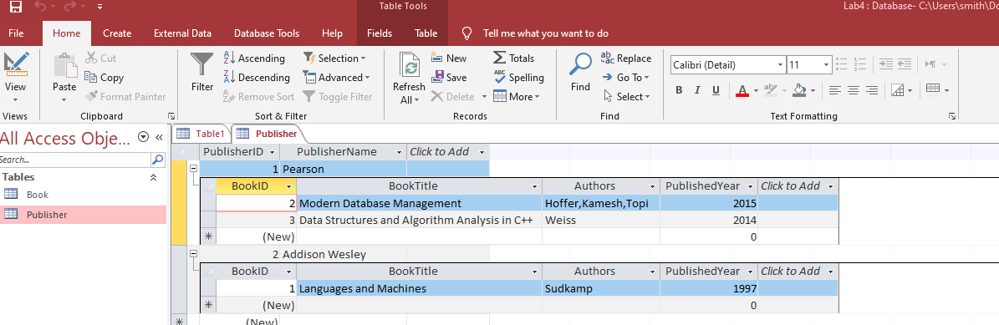

b. the book table is in 0NF because the author column is multivalued. In order bring book table into 3NF we would first have to create a new record for each author. WE would then have to establish a candidate key, and separate the relationships. I would create a book relation into a new entity. Once no transitive functional dependency exists we are in 3NF.

Part 2

Start:

VideoData (VideoID, VideoTitle, Username, UserTier, MinTierFollowers, StreamStart, VideoDuration, ContentRating, RatingDescription)

Relational Notation:

User (UserName,UserTier,MinTierFollowers)

Rating(VideoTitle, ContentRating,RatingDescription)

VideoData (VideoID, *VideoTitle*, *Username*, StreamStart, VideoDuration)